Write a code using Terraform that deploys and achieves the following:-
- Create an EC2 Instance on AWS Cloud using the below-mentioned ubuntu AMI and instance_type. Or, (You can use of your choice as well) ami = "ami-0461b1436c9b3c1a3" instance_type = "t2.micro"
- Install a web server on the same EC2 Instance. The web server should listen on port 8080.
- Create a Docker-compose file for the project: https://github.com/ALEEMUDDIN138/cricbuzz-docker-hello-world.git and point it to port 8000.
- Make the web server point to the above service so that 8080 returns the response from the Docker service.
main.tf:
provider "aws" {
region = "us-east-1"
}
# Data source to get the default VPC
data "aws_vpc" "default" {
default = true
}
# Data source to get a subnet from the default VPC
data "aws_subnets" "default" {
filter {
name = "vpc-id"
values = [data.aws_vpc.default.id]
}
}
# Data source to reference the existing security group
data "aws_security_group" "web_sg" {
name = "web_sg_unique"
vpc_id = data.aws_vpc.default.id
}
# EC2 Instance
resource "aws_instance" "web_server" {
ami = "ami-0360c520857e3138f" # Specified Ubuntu AMI
instance_type = "t3.micro"
key_name = "Virginia" # Ensure this key pair exists in AWS
vpc_security_group_ids = [data.aws_security_group.web_sg.id]
subnet_id = data.aws_subnets.default.ids[0]
associate_public_ip_address = true
user_data = <<-EOF
#!/bin/bash
LOG="/var/log/cb.log"
echo "Starting user_data script at \$(date)" > $LOG
# Update & install dependencies
apt-get update -y >> $LOG 2>&1 || { echo "Failed to update packages" >> $LOG; exit 1; }
apt-get install -y nginx docker.io git curl logrotate >> $LOG 2>&1 || { echo "Failed to install packages" >> $LOG; exit 1; }
# Enable & start Docker
systemctl enable docker >> $LOG 2>&1 || { echo "Failed to enable Docker" >> $LOG; exit 1; }
systemctl start docker >> $LOG 2>&1 || { echo "Failed to start Docker" >> $LOG; exit 1; }
# Install Docker Compose
DOCKER_COMPOSE=/usr/local/bin/docker-compose
curl -L "https://github.com/docker/compose/releases/download/v2.20.2/docker-compose-$(uname -s)-$(uname -m)" -o $DOCKER_COMPOSE >> $LOG 2>&1 || { echo "Failed to download Docker Compose" >> $LOG; exit 1; }
chmod +x $DOCKER_COMPOSE || { echo "Failed to make Docker Compose executable" >> $LOG; exit 1; }
# Clone application
APP_DIR=/home/ubuntu/cricbuzz-docker-hello-world
mkdir -p /home/ubuntu
cd /home/ubuntu
if curl --output /dev/null --silent --head --fail https://github.com/ALEEMUDDIN138/cricbuzz-docker-hello-world.git; then
if ! git clone https://github.com/ALEEMUDDIN138/cricbuzz-docker-hello-world.git $APP_DIR >> $LOG 2>&1; then
echo "Failed to clone repository, creating fallback app" >> $LOG
mkdir -p $APP_DIR
cd $APP_DIR
# Fallback Dockerfile
cat <<EOD > Dockerfile
FROM python:3.9-slim
WORKDIR /app
RUN pip install flask
COPY . .
EXPOSE 8000
CMD ["python", "app.py"]
EOD
# Fallback Flask app
cat <<EOD > app.py
from flask import Flask
app = Flask(__name__)
@app.route('/')
def hello():
return 'Hello, World!'
if __name__ == '__main__':
app.run(host='0.0.0.0', port=8000)
EOD
else
cd $APP_DIR
# Check if Dockerfile and required files exist
if [ ! -f Dockerfile ] || ! grep -q "COPY ./hello_world" Dockerfile || [ ! -f hello_world ]; then
echo "Repository Dockerfile is missing or invalid, using fallback" >> $LOG
# Fallback Dockerfile
cat <<EOD > Dockerfile
FROM python:3.9-slim
WORKDIR /app
RUN pip install flask
COPY . .
EXPOSE 8000
CMD ["python", "app.py"]
EOD
# Fallback Flask app
cat <<EOD > app.py
from flask import Flask
app = Flask(__name__)
@app.route('/')
def hello():
return 'Hello, World!'
if __name__ == '__main__':
app.run(host='0.0.0.0', port=8000)
EOD
fi
fi
else
echo "Repository not accessible, creating fallback app" >> $LOG
mkdir -p $APP_DIR
cd $APP_DIR
# Fallback Dockerfile
cat <<EOD > Dockerfile
FROM python:3.9-slim
WORKDIR /app
RUN pip install flask
COPY . .
EXPOSE 8000
CMD ["python", "app.py"]
EOD
# Fallback Flask app
cat <<EOD > app.py
from flask import Flask
app = Flask(__name__)
@app.route('/')
def hello():
return 'Hello, World!'
if __name__ == '__main__':
app.run(host='0.0.0.0', port=8000)
EOD
fi
cd $APP_DIR
# Build Docker image
if ! docker build -t cricbuzz-local . >> $LOG 2>&1; then
echo "Docker build failed, attempting fallback build" >> $LOG
# Fallback Dockerfile
cat <<EOD > Dockerfile
FROM python:3.9-slim
WORKDIR /app
RUN pip install flask
COPY . .
EXPOSE 8000
CMD ["python", "app.py"]
EOD
# Fallback Flask app
cat <<EOD > app.py
from flask import Flask
app = Flask(__name__)
@app.route('/')
def hello():
return 'Hello, World!'
if __name__ == '__main__':
app.run(host='0.0.0.0', port=8000)
EOD
docker build -t cricbuzz-local . >> $LOG 2>&1 || { echo "Fallback Docker build failed" >> $LOG; exit 1; }
fi
# Docker Compose file
cat <<EOT > $APP_DIR/docker-compose.yml
version: '3'
services:
web:
image: cricbuzz-local
ports:
- "8000:8000"
restart: always
EOT
# Start container
docker-compose -f $APP_DIR/docker-compose.yml up -d >> $LOG 2>&1 || { echo "Failed to start Docker container" >> $LOG; exit 1; }

# Wait for app to be ready
sleep 60
# Verify Flask app is running
if ! curl --fail http://127.0.0.1:8000 >> $LOG 2>&1; then
echo "Flask app failed to start" >> $LOG
exit 1
fi
# Remove default Nginx site to avoid conflicts
rm -f /etc/nginx/sites-enabled/default >> $LOG 2>&1
# Configure Nginx to listen on port 8080
cat <<EOT > /etc/nginx/sites-available/cricbuzz
server {
listen 8080;
server_name _;
access_log /var/log/cb.log;
error_log /var/log/cb.log;
location / {
proxy_pass http://127.0.0.1:8000;
proxy_set_header Host \$host;
proxy_set_header X-Real-IP \$remote_addr;
proxy_set_header X-Forwarded-For \$proxy_add_x_forwarded_for;
proxy_set_header X-Forwarded-Proto \$scheme;
}
}
EOT
# Link Nginx configuration
ln -sf /etc/nginx/sites-available/cricbuzz /etc/nginx/sites-enabled/cricbuzz >> $LOG 2>&1 || { echo "Failed to link Nginx config" >> $LOG; exit 1; }
# Configure logrotate for /var/log/cb.log
cat <<EOT > /etc/logrotate.d/cricbuzz
/var/log/cb.log {
daily
rotate 7
compress
delaycompress
missingok
notifempty
create 0640 www-data ubuntu
postrotate
/usr/sbin/nginx -s reload
endscript
}
EOT
# Test and restart Nginx
if ! nginx -t >> $LOG 2>&1; then
echo "Nginx configuration test failed" >> $LOG
exit 1
fi
systemctl restart nginx >> $LOG 2>&1 || { echo "Failed to restart Nginx" >> $LOG; exit 1; }
systemctl enable nginx >> $LOG 2>&1 || { echo "Failed to enable Nginx" >> $LOG; exit 1; }
# Test logrotate configuration
logrotate -d /etc/logrotate.d/cricbuzz >> $LOG 2>&1 || { echo "Failed to test logrotate config" >> $LOG; exit 1; }
echo "user_data script completed successfully at \$(date)" >> $LOG
EOF
tags = {
Name = "Cricbuzz-Web-Server"
}
}
# Output the public IP of the EC2 instance
output "instance_public_ip" {
value = aws_instance.web_server.public_ip
}
AMI ID is invalid taken other ami
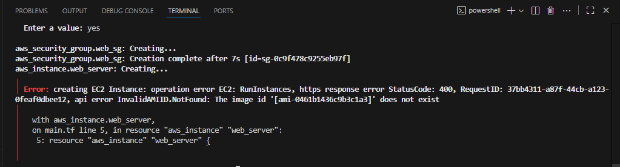
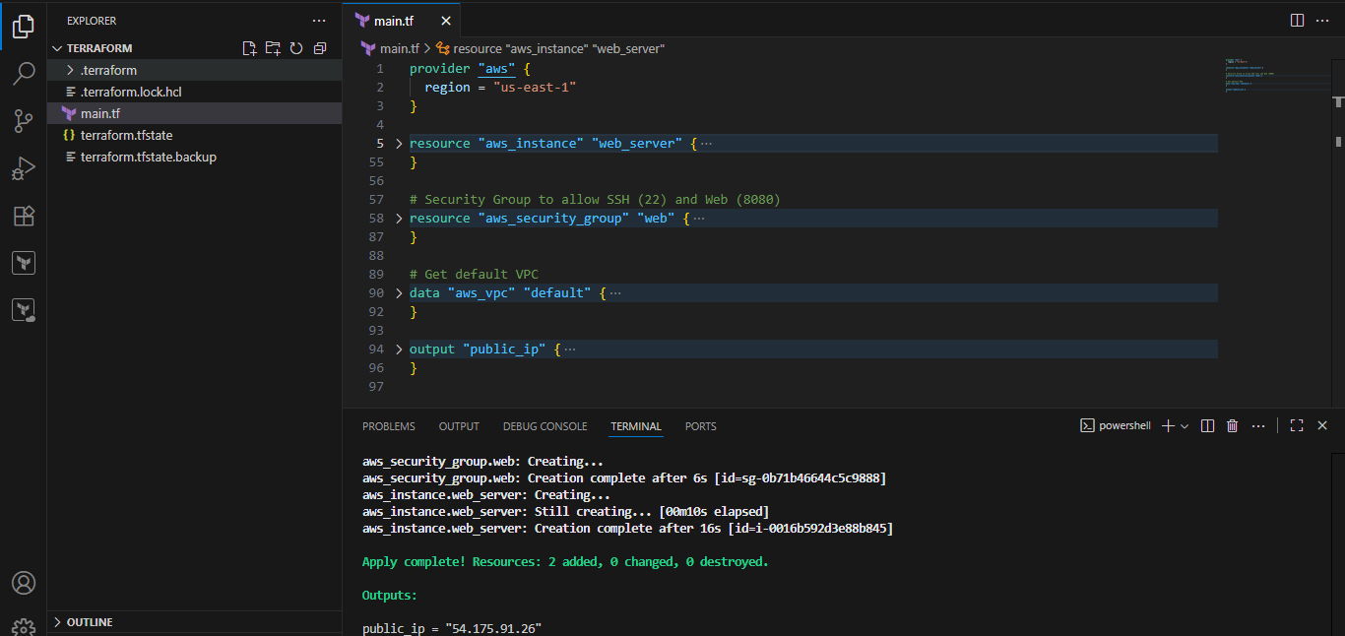

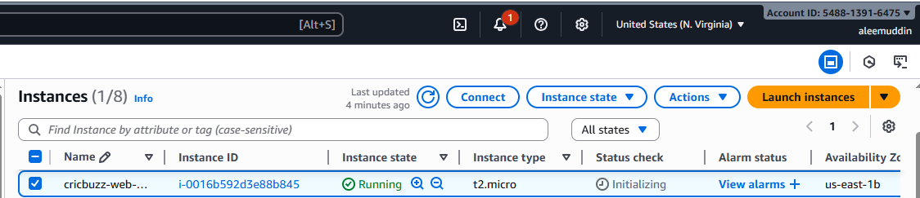
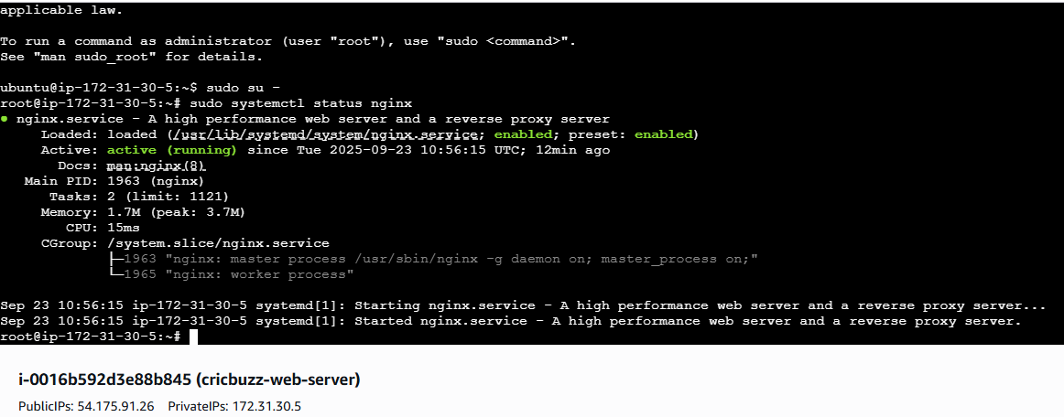
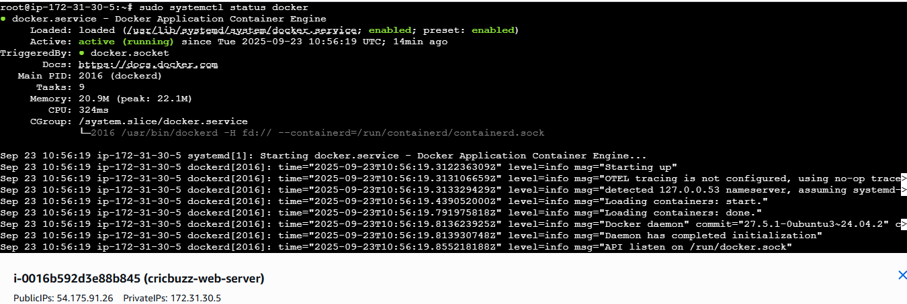
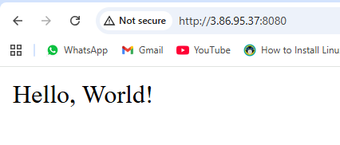
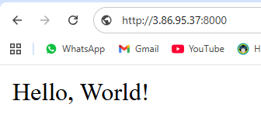
- Configure to Save the Logs in the location /var/log/cb.log.
From root location
cd /var/log/
cat cb.log
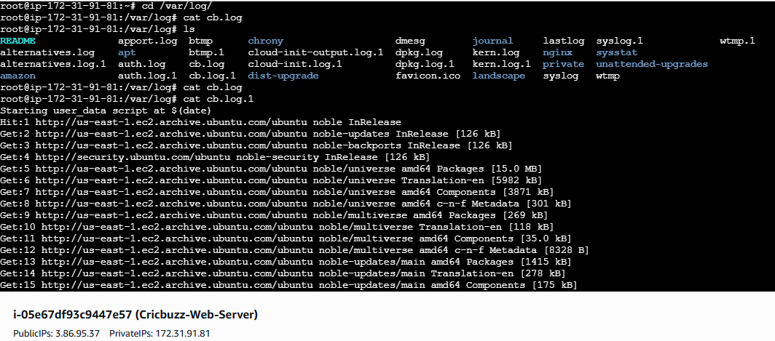
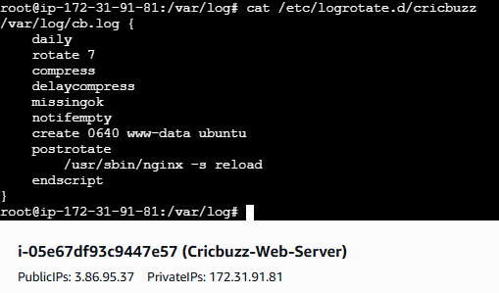
- Write the Log rotate configuration for the above file.
This Terraform task sets up a web application on AWS using an EC2 instance. Here's why it's useful in simple terms:
- Creates a Server Automatically:
  - It launches an AWS EC2 instance (a virtual server) with Ubuntu and a t3.micro type (small, cost-effective).
  - Terraform automates this, so you don’t have to manually set up the server, saving time and avoiding mistakes.
- Runs a Web Server (Nginx):
  - Installs Nginx to listen on port 8080, acting as the front door for your web application.
  - Use: Lets users access your app via a web browser or API call on port 8080.
- Deploys a Docker App:
  - Clones a project (cricbuzz-docker-hello-world) and runs it in a Docker container on port 8000.
  - If the project has issues (like missing files), it uses a backup Flask app that says "Hello, World!".
  - Use: Docker makes the app easy to run, update, or move to other servers.
- Connects Nginx to Docker:
  - Nginx forwards requests from port 8080 to the Docker app on port 8000.
  - Use: Users visit http://<server-ip>:8080 and see the Docker app’s response, keeping the backend secure.
- Saves Logs to /var/log/cb.log:
  - All setup steps (installing software, running Docker) and Nginx activity (access and errors) are logged to /var/log/cb.log.
  - Use: Helps you check what’s happening on the server and fix issues (e.g., why something failed).
- Manages Logs with Logrotate:
  - Rotates /var/log/cb.log daily, keeps 7 days of logs, and compresses old ones to save space.
  - Use: Prevents the log file from getting too big, making it easier to manage long-term.
Why Is This Task Useful?
- Quick Setup: Automates setting up a web server and app, ready to use in minutes.
- Learning: Teaches you how to use Terraform, AWS, Docker, and Nginx together.
- Debugging: Centralized logs (/var/log/cb.log) make it easy to find and fix problems.
- Scalable: You can modify it for bigger apps or more servers later.
- Reliable: The fallback Flask app ensures the app works even if the GitHub project fails.
Logrotate Configuration
As you specifically asked for the logrotate part, here it is in simple terms:
- It manages the /var/log/cb.log file by:
  - Creating a new log file daily.
  - Keeping only 7 days of logs.
  - Compressing old logs to save space.
  - Ensuring Nginx keeps working after rotation.

